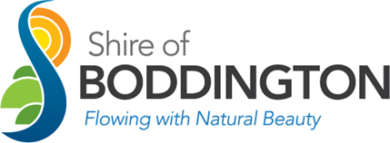

Community Grant Program
Acquittal Form 2022-23

Applicant Details

This is the group which undertook the project and the person legally authorised to enter into contracts on behalf of the organisation. This is generally the president or chairperson.

Legal Name of Organisation
Organisation Name
Position
Telephone
Mobile
Email

Project Details

Outline how the grant funds were used.

Describe how the project benefited those participating and the community of Boddington

How did you acknowledge the Shire of Boddington’s contribution to the project?

Budget Details

Use the table below to demonstrate how the approved funding amount was used by listing the expenses your project incurred. Please note Shire of Boddington’s contribution is limited to 75% of the total project expenditure, and no more than $2,000.

Grant Amount | $
Funds Spent | $
Unspent Funds | $

Expenditure
Expenditure Items | Amount

Declaration

I declare the organisation has read and understood the Community Grant Program Guidelines.

I declare I am the authorised person to submit this application on behalf of my organisation and are authorised to sign legal documents on behalf of the organisation.

I declare the information provided in this application and attachments is to the best of my knowledge true, correct and discloses all estimates as accurate as possible.

I have attached supporting documentation (including receipts or invoices).

I understand false or misleading statements listed in this Community Grant Program Acquittal can result in disqualifying the organisation from future funding.

Name |  | Position
Signature |  | Date

